Uncovering Cyberbullying using
Machine Learning

Dr. M. Sakthivel  Professor, Dept of CSE  Sree Vidyanikethan Engineering College,  Tirupati, Andhra Pradesh, India | V. Nagesh,  UG Scholar, Dept of CSE  Sree Vidyanikethan Engineering College,  Tirupati, Andhra Pradesh, India | V. Ganga Pradeep,  UG Scholar, Dept of CSE  Sree Vidyanikethan Engineering College,  Tirupati, Andhra Pradesh, India
V. Hemanth Kumar Reddy,  UG Scholar, Dept of CSE  Sree Vidyanikethan Engineering College,  Tirupati, Andhra Pradesh, India | V. Sindhura,  UG Scholar, Dept of CSE  Sree Vidyanikethan Engineering College,  Tirupati, Andhra Pradesh, India | T. Chirudeep  UG Scholar, Dept of CSE  Sree Vidyanikethan Engineering College,  Tirupati, Andhra Pradesh, India

I ABSTRACT

As cyberbullying has become increasingly common, there has been a lot of focus on cyberbullying detection because cyberbullying has a fatal effect on both users of social media platforms and society. Social media has become a channel for many people to communicate their opinions, knowledge, and so on. It would have been one of the best things if it had not become a tool for many people to exact revenge, manipulate others, or harass and humiliate others. As a result, we do not require a monitoring system to control the misbehavior and bullying that spreads through social networks, which has led to the development of this model to automate the identification of cyberbullying. “Our main goal is to create a model that categorizes comments as positive or negative.

Keywords
Cyber Bullying, Sentiment Analysis, Personality Analysis.

II Introduction
Cyberbullying is just bullying or harassing others via various Social Media platforms. As the technological era has progressed, the use of social media platforms has skyrocketed, with more than half of the world's population now utilizing them. As its popularity has grown, a piece of news or other information can now be shared with others in seconds. This is now one of its most essential applications. However, some people took advantage of this and began to seek enjoyment from it. Cyberbullying has since begun and has grown significantly.
Cyberbullying is known as an unseen crime, and many victims have been tormented online through toxic comments. Research suggests that approximately 50% of children have been affected by cyberbullying, resulting in a range of negative consequences such as mental health issues, academic struggles, and even suicidal thoughts. Unfortunately, many victims do not receive the help and support they need due to factors such as social status. In addition to the emotional toll, cyberbullying can also damage a person's reputation through the spread of false rumors and harmful content. Approximately 8 out of 10 children are victims of various forms of cyberbullying.. Machine learning is used to detect cyberbullying by identifying and classifying instances of online harassment, abuse, and bullying. This technique often entails training a model on a large dataset of cyberbullying cases as well as non-cyberbullying text examples. The model can then be used to predict whether future occurrences of online text are likely to be cyberbullying. Personality Analysis, Sentiment Analysis, and User Traits are some of the factors that the algorithm takes into account while making these predictions. The purpose of this technique is to create a rapid, scalable, and automated mechanism to detect and solve cyberbullying, so that online communities can be safer and more supportive for everyone.
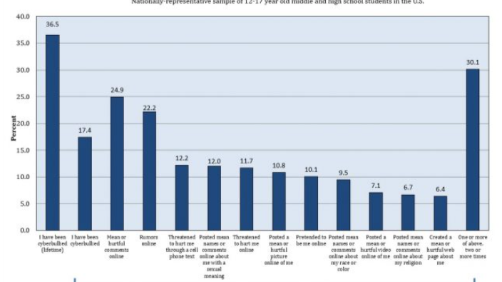

Fig.1.CyberBullying Victimization and Reasons

There have been numerous incidents of cyberbullying, ranging from a mother seeking vengeance for her child, which resulted in the suicide of a thirteen-year-old girl, to people tormenting others for the sake of pleasure.Initially, this was taken casually, and there were no rules governing it. However, it has grown swiftly, and many individuals are victims of it. Despite the fact that there are numerous laws in place to punish individuals who bully others. Despite this, the number of has never dropped. So we're opting for a preventative technique in which we'll employ a machine learning model to recognize phrases and sentences that are used to injure or harass people and then replace them with positive comments. Here, we'll apply the concept of ensemble algorithms to improve the model's accuracy.
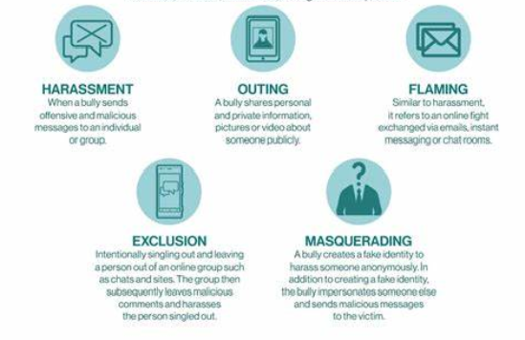

Fig.2.Types of CyberBullying

RESEARCH OBJECTIVES

1. We would be using various machine Learning Techniques to build a model that accurately identifies instances of cyberbullying.
2. To develop a model that Classifies the type of cyberbullying being used .Various types of cyberbullying being harassment, threats, spreading rumors, Flaming etc.
3. To train and test the model using the twitter dataset that is available online.
4. The dataset consists of both positive and negative contexts of cyberbullying.
5 .The primary objective is to reduce the rate of cyberbullying.
6. Optimize the performance of model using ensemble algorithms.

III SCOPE OF THE WORK

The proposed work will utilize the supervised learning approach to detect and address cyberbullying. The dataset will consist of two categories of data, positive and negative, related to cyberbullying. The goal is to identify instances of cyberbullying and transform negative comments into positive forms. The work will involve implementing multiple machine learning algorithms.

IV PROBLEM STATEMENT

Cyberbullying is the use of numerous social media platforms to manipulate, torment, or harass another person, and it is a developing concern in today's technology day. With the increased use of online platforms, cyberbullying has increased significantly, causing a slew of serious issues in victims such as depression and inferiority complexes. Machine Learning has various sets of algorithms that are used to develop various types of predictive models. This has simplified many challenges, one of which is cyberbullying detection. Cyberbullying has become more common as the use of social media platforms has grown.

V LITERATURE SURVEY

The field of Machine Learning offers diverse algorithms that aid in the creation of predictive models for various applications, including the detection of cyberbullying. With the increasing use of social media platforms, cyberbullying has become prevalent, necessitating the need for models that can recognize such instances in real-time, given the constant growth of data. This can be achieved by utilizing machine learning techniques such as Bayes, Decision Tree, and Foresting, as well as ensemble algorithms that optimize the model.

A RELATED WORK:

Andreas Weiler et al investigated the run-time and task-based performance of numerous Twitter event recognition algorithms. The writers took a two-pronged approach. The scholars gathered a dataset of cyberbullying-related tweets and developed a ML classifier to identify cyberbullying tweets, the classifier used a SVM classifier algorithm and a collection of variables such as sentiment analysis, frequency of abusive terms, and user mentions.

Chen et al. (2012) conducted a study that developed a method for detecting offensive language using a syntactic element which outperformed the standard learning-based method. In a similar study, Dadvar et al. (2013) utilized SVM to detect cyberbullying in YouTube data and found that integrating user-generated content improved the results of SVM detection. Dadvar et al. used MySpace data sets to reach their conclusions.

The research conducted by Cynthia Van Hee and Gilles Jacobs focused on automatic cyberbullying identification in social media text. They gathered data from social networking sites and used online bullying standards to create corpora for modeling postings made by bullies and victims. Common natural language processing pre-processing steps such as tokenization and lemmatization were utilized to convert unstructured text into a structured text that can be used for Classification and Regression algorithm. The researchers also tested language conversion by constructing models for both English and Dutch. Although the accuracy results of 64% for English and 61% for Dutch were modest, they serve as a promising starting point for further research and improvements to the SVM ML algorithm. The complexity and diversity of language used in social media communication make automatic cyberbullying identification in social media text a challenging task.

Hannah L. Schacter et al investigated how cyberbullying victims' disclosures on Facebook influence bystanders' features of guilt, empathy, and ideas of intervening on behalf of a casualty following the completion of a cyberbullying incident. The researchers chose 118 participants at random to read the Facebook page of a cyber-victim who had posted an update with varied levels of personal disclosure and valence. (i.e., positive or negative tone).The study's findings revealed that participants who examined the high personal disclosure profile, regardless of valence, blamed the victim more and felt less empathy for the victim. As a result, the likelihood of bystander intervention in the bullying incidence was anticipated to be lower. According to the authors, this effect may be attributable to the victim's perceived responsibility and deservingness based on their level of personal exposure.

The study by S.E. Vishwapriya, Ajay Gour, and their team on uncovering hate speech and objection language on Social media tweet is noteworthy. The researchers utilized labeled datasets from Crowdflower and GitHub, which had categories such as Hateful, Offensive, Sexism, and Racism. They pre-processed the data by performing various text cleaning tasks, including lowercasing tweets, removing URLs, stop words, and Twitter mentions, and using stemming. They also divided the dataset into 70% training and 30% test samples, which is a standard practice in machine learning. The team employed N-gram features with TF-IDF weighting, which is a popular approach for text classification. These findings suggest that their approach has great potential for automated detection and prevention of hate speech and objectionable language on Twitter.

Matthew Pittman and Brandon Reich performed a mixed-design survey to investigate whether text- and image-based social media sites like Twitter and Yik Yak, as well as platforms like Instagram and Snapchat, can help reduce loneliness by promoting more intimacy. Since young adults are the group most likely to use social media and experience loneliness, they were the focus of their study. Both quantitative and qualitative information from the survey was analyzed by the researchers. Use of text-based media, in contrast, seemed ineffectual in this regard. The qualitative findings revealed that the increased intimacy provided by image-based social media use was what caused the observed impacts. Using image-based social media platforms reportedly increased participants' sense of community and sense of shared experience.
College students' experiences with various types of social media cyberbullying on social networking sites were the subject of a study by Kassandra Gahagan. (SNS). The study's findings revealed that 46% of college students had seen cyberbullying on SNS and that 19% of them had experienced bullying on the platform. In addition, 61% of college students who saw cyberbullying on SNS took no action. The college students were asked about their experiences with cyberbullying as well as their perceptions of their responsibilities when they observed cyberbullying on SNS. Two distinct themes that arose from the responses were found by the study. Some college students thought their duty to step in depended on the circumstances, while others said there was a consistent, obvious level of obligation for college students who witnessed cyberbullying on SNS. According to the study's findings, college students frequently engage in cyberbullying on social networking sites, and bystander assistance is frequently missing. The report also emphasizes the necessity of bystander education and awareness efforts to encourage appropriate and proactive behavior in cases of cyberbullying.
H. Watanbe, M. Bouaizi, and T. Ohtsui's research on detecting hate speech on Twitter using unigrams and automatically gathered patterns. It's interesting to see that they employed three different datasets to train and evaluate their model, which included tweets categorized as clean, offensive, hateful, sexist, racist, or neither. Pooling these datasets together is a common approach to create a larger and more diverse dataset for machine learning. Pre-processing steps such as removing URLs and tags from tweets, as well as lemmatization, part of speech tagging, and tokenization are commonly used in natural language processing to transform unstructured text into structured format that can be used for machine learning algorithms.Using unigrams and automatically gathered patterns from the dataset is a popular approach for text classification tasks, especially for detecting hate speech and offensive language. However, it's important to note that unigrams may not capture the full context and meaning of the text, so it may be necessary to consider other features such as bigrams, trigrams, or even semantic features.
In their research, Lida Ketsbaia, Biju Issac, and colleagues focused on identifying harmful texts using ML and Deep learning. One notable aspect of their approach was the use of datasets from two different universities, with one labeled as "Hate" and the other labeled as "Non-Hate," to train their model. This allowed them to create a more diverse and comprehensive dataset for their research.
VI METHODOLOGY

We use various machine learning algorithms together to detect the context of cyberbullying. Here we will be using a different algorithms to uncover cyberbullying on the labelled dataset .The dataset has both the positive comments and negative comments .we will be using various algorithms like naïve bayes ,Random Forest and decision tree .Next we are going to combine all these using ensemble algorithms which are going to give us the optimized output .The performance also increases .Along the bunch of words here we would be concentrating on personality analysis .
The dataset is first collected, then divided into two halves. Training accounts for 75% of the time while testing accounts for 25%. Then, various machine learning techniques are used to build the model .Then this model is used to predict the context of cyberbullying.

A MODEL DESCRIPTION

Building a machine learning model to identify cyber bullying requires several steps:
Data Collection:
To build a machine learning model for identifying cyberbullying, the first step is to gather a comprehensive and varied dataset of text that includes examples of both offensive and non-offensive tweets. This dataset can be obtained from social media platforms, online forums, and comments sections. The aim is to ensure that the dataset is large and diverse, with a wide range of texts representing different contexts and scenarios. This will allow the model to learn and generalize from the data effectively, resulting in better performance.
Data Preprocessing:
In the data preprocessing step, the collected data is cleaned and standardized to prepare it for machine learning algorithms. This involves removing irrelevant information like URLs and special characters that may interfere with the analysis process. Additionally, text normalization techniques like converting all text to lowercase may be applied to ensure consistency in the data. The goal of data preprocessing is to obtain a clean dataset that can be used for feature engineering and model training.
Feature Extraction:
Feature extraction is a crucial step in building a machine learning model for text classification. It involves selecting the features that the model will use to make its predictions. In the case of text, this typically involves creating numerical representations of the text that capture the most important information. This can be achieved through technique word embeddings, which convert the text into numerical vectors. These features are then used as input to the classifier algorithms for training, testing and prediction.

Model Selection:
Choose an appropriate algorithm for the task of text classification, such as a SVM Classifieror a foresting algorithm.
Model Training:
Train the model on the preprocessed and feature-engineered data. This involves providing the model with the features and corresponding labels (e.g., cyber bullying or non-cyber bullying) for each instance in the training data.
Model Evaluation:
After building and fine-tuning the model, it's essential to evaluate its performance. The evaluation step to test the model on a separate test dataset and computing metrics such as accuracy, precision, confusion matrix. These metrics help to assess the model's effectiveness in detecting cyberbullying. By evaluating the model's performance, we can identify potential areas for improvement and fine-tune the model further to enhance its accuracy and effectiveness in detecting cyberbullying.
Model Fine-tuning:
Fine-tuning the model involves adjusting its parameters or testing different algorithms to improve its performance, and repeating the evaluation step if necessary. This step is crucial as it helps to optimize the model and improve its accuracy. Contingent upon the consequences of the assessment, the model might should be tweaked by changing its boundaries or attempting an alternate calculation to accomplish improved results. By repeating the evaluation step, we can assess whether the changes made to the model have improved its performance. Overall, fine-tuning is a necessary step in the model development process to ensure that the model is as accurate and effective as possible.

B Cyber bullying detection Model :
The cyberbullying detection framework consists of two key components: N L Processing (NLP) and Artificial Intelligence. To train our model, we collected real-time tweets from various internet sources and platforms. Pre-processing text data is an essential step in NLP to standardize the data and remove unwanted characters such as emojis, special characters, and punctuation that may interfere with the analysis and modeling process. Therefore, we cleaned and prepared the data for detection by removing unwanted patterns such as numerical characters, hashtags, and special symbols using numpy and vectorize routines.

We then utilized NLP techniques such as tokenization, lemmatization, and vectorization to transform raw text into numerical vectors. After completing pre-processing, we divide the dataset into test data and train data. We used two significant text selection functions, Inverse Frequency and Count Vectorizer, to train our model. We also employed a variety of machine learning algorithms such as svm, decision tree, naive bayes, Logistic Regression, Random Forest, and K Neighbours Classifier to evaluate the accuracy for each model in the second phase.

To find the best suitable combination of dimension selection methods such as term frequency-inverse document frequency and count vectorizers and machine learning models, we compared both TF-IDF and count vectorizer. Using these techniques, our model can predict whether the text belongs to the context of bullying or not in English.
- Data collection
We collected a dataset consisting of both English and Hinglish text, which contained tweets from various social media platforms and networking websites. The dataset consisted of approximately 15,307 entries in English, and for the Hinglish dataset, we extracted tweets and WhatsApp messages in real-time, resulting in approximately 9,482 entries in total. Human annotators manually labeled all entries as toxic or non-toxic. In addition, we extracted tweets and comments from YouTube and Twitter chats, which were combined to create a larger dataset of approximately 3000 entries. The dataset contains two columns: Tweets and Labels, with labels representing bullying, non-bullying, and offensive messages with numbers 0, 1, and 2, respectively. This diverse collection of messages helps in detecting offensive contexts in tweets effectively. However, since real-time data often contains unwanted characters and symbols, preprocessing the data is a crucial yet time-consuming step to prepare it for the detection process.
ii. Data Preparation
In order to prepare the data for machine learning models, it is crucial to clean the data by removing unnecessary characters, symbols, and stopwords. This step can significantly enhance the accuracy of the model and prevent overfitting. It is commendable that you have already taken the necessary steps to clean the data and remove unwanted words and symbols. Additionally, it is worth noting that while a manual list of stop words can be helpful, there are also pre-built libraries and packages that can automatically remove stop words based on the language. These packages can be time-saving and further improve the accuracy of the cleaning process.
iii. Preprocessing Methodologies
Because the algorithm cannot operate directly with unordered and uncleaned text—that is, it cannot understand the sentences provided to it—we used natural language processing techniques after cleaning the data. To do this, we transformed the sentences into an understandable format using some preprocessing techniques. We use the following
• Tokenization - Breaking down a text sequence into smaller units, or tokens, like words, phrases, ideas, and symbols, is referred to as tokenization. It is a critical stage in natural language processing and is frequently carried out as a pre-processing stage before text data is fed into machine learning models. Tokenization enables the efficient analysis and processing of text by dividing it into smaller units that can be processed more easily, leading to more accurate natural languages processing tasks like sentiment analysis, part-of-speech and text classification. Tokenization can be performed at various levels, including word level, sentence-level, and document level.

• Lemmatization - Lemmatization is a crucial process in natural language processing that involves transforming a word into its base. This process is important because it helps to decrease the number of distinct words and variations present in a text document, thus improving the accuracy of text analysis. An example of lemmatization is converting the word "running" to its lemma "run," and the word "better" to its lemma "good."
Vectorization is a method used in natural language processing to turn text data into numerical vectors that machine learning algorithms can process. In this process, words or documents are represented as numerical vectors, each of whose dimensions denotes a distinct characteristic. The vector's values represent each feature's relative weight or significance, allowing the algorithm to comprehend the text data and base its predictions on it.
iv. Data segmentation:
In the process of building a machine learning model for text analysis, namely training data and testing data. The testing data is obtained by extracting text data from various sources using techniques such as text mining. Both the training and testing data go through preprocessing steps and are then used for training and evaluating multiple machine learning models. This segmentation of data helps in ensuring that the developed model performs well on unseen data and can be used effectively in real-world applications.
v. Feature choice:
After separating the data, an essential NLP step called feature selection entails extracting pertinent text features. This technique aids in evaluating the precision of the final vector representations. It works by locating words with comparable meanings that frequently occur close to terms. The text features are then vectorized into numerical vectors before the data is fed into the machine learning models for training and assessment.
1) Count Vectorization: A common Natural Language Processing (NLP) method called count vectorization turns a group of written documents into a matrix of token counts. This method entails breaking the text down into individual words or tokens, noting the frequency of each token within the document, and then converting the counts into numerical values. The outcome is a sparse matrix of integers, where each row denotes a document and each column denotes a distinct token within the collection. Numerous NLP applications, including document classification, sentiment analysis, and topic modeling, depend on count vectorization as a basic step.
2) TF-IDF: TF-IDF, an acronym for Term Frequency-Inverse Document Frequency, is a numerical metric that measures the relevance of a word in a document within a corpus. This metric is frequently employed in natural language processing and information retrieval to conduct text analysis and ranking in search engines. The importance of a word is determined by both its frequency in the document and the frequency of the word in the corpus.

1) SVM (Support Vector Machine): Support Vector Machines (SVMs) are a class of machine learning algorithm that have been extensively used in many fields, including image classification, text classification, and bioinformatics. SVMs are an example of supervised learning algorithms, which means that in order to teach them, labelled data is necessary. The objective of SVMs is to identify a hyperplane that has a maximum distance from the closest data points in each class and separates the various classes of data with the greatest possible margin.
2) KNN (K Neighbors): Machine learning techniques like the K-Nearest Neighbors (KNN) method are frequently employed in classification and regression analysis. KNN is a non-parametric method, which means it doesn't assume anything about how the data are distributed. Instead, it locates the K data points in the training set that are closest to a new data point, and then labels the new data point with the plurality of the K nearest neighbours.
3) Logistic Regression: This technique employed for binary classification problems where the outcome variable has only two potential results. The primary objective of logistic regression is to determine the most appropriate S-shaped curve for the target variable
The logistic regression model uses the maximum likelihood estimation approach to compute the sigmoid function's parameters. The model aims to identify the coefficient values that maximize the probability of the input features given the observed data. This optimization problem is resolved utilizing various optimization algorithms such as gradient descent.
Logistic regression is an effective algorithm that is simple to interpret and has low computational requirements. The algorithm can handle non-linear relationships between the input features and the target variable by including polynomial or interaction terms into the model. However, logistic regression presupposes that the input features are independent and linearly associated with the target variable, which may not always be valid in real-world applications.
4) Decision Tree Learning: In the field of research, decision trees have proven to be a useful method for detecting instances of cyberbullying. This supervised learning technique involves categorizing data into multiple groups based on certain criteria. Decision trees can be applied in cyberbullying detection to analyze various forms of online content, including text, photos, and videos, and determine whether they constitute cyberbullying or not. In case the model's performance is not satisfactory, one can adjust its settings or redefine its characteristics to enhance its accuracy. By repeating this process, a more effective decision tree model for detecting cyberbullying can be developed. Overall, decision trees can be a valuable technique for detecting cyberbullying in studies. Decision trees can help identify instances of cyberbullying and aid in the creation of effective intervention techniques by examining aspects of online content.

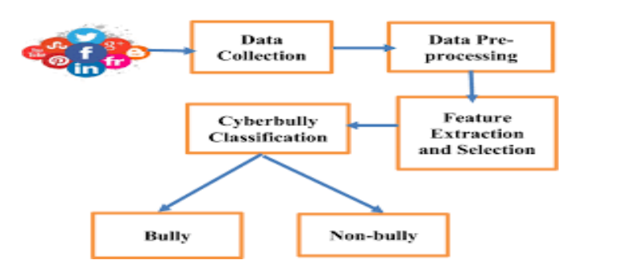

Fig.3.Model

3.4 DATASET DESCRIPTION:

The dataset is the snapshot of the twitter information during a particular period of time .
It consists of tweets from all kinds of users .It has seven columns na--mely 'Unnamed,'count', 'hate_speech' , 'offensive_language ', 'neither', 'class', 'tweet '.
The class is our dependent variable and remaining
are the independent varibles .The class consists of numeric values so we would be converting them into discrete values by labelling them.The dataset have nearly 24000 rows .we would be partitioning it for testing and training .
It does not have any missing values or inconsistent
values .
The tweets is the most important variable as we are going to use it for classifying the comments .The class is our target variable one which will be predicted.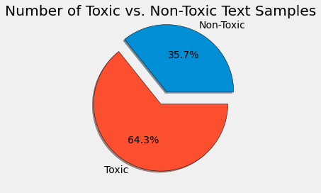
Top 20 words used in cyberbullying tweets:
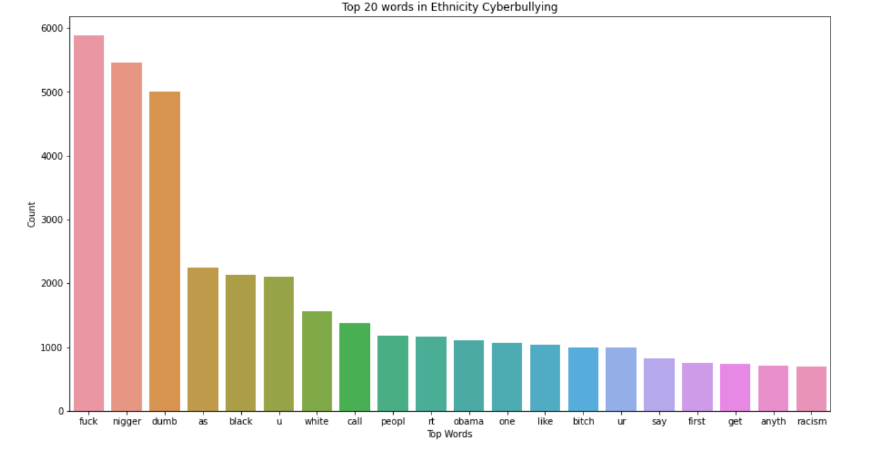

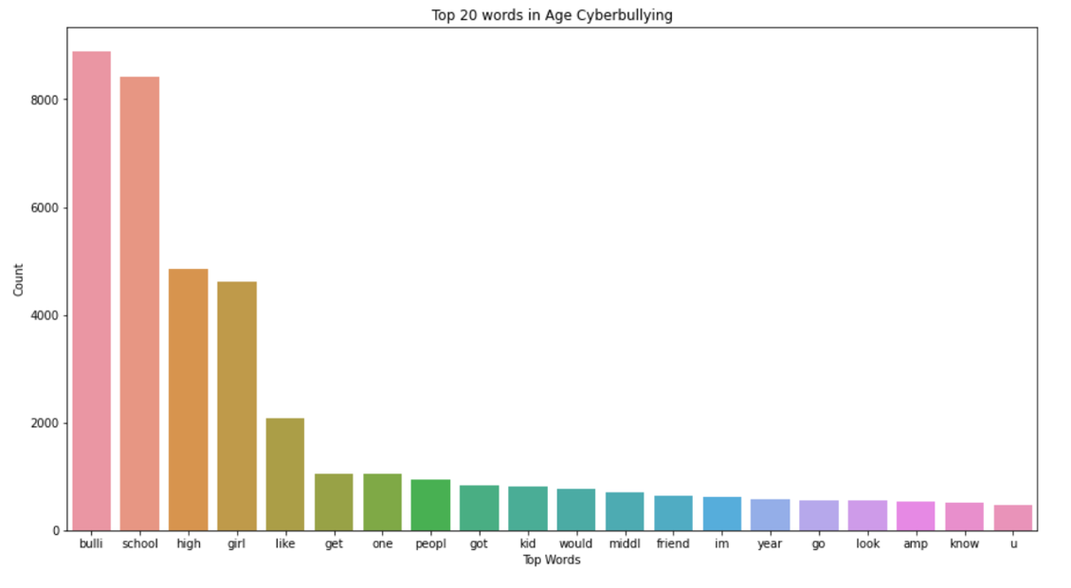

VII EXPERIMENTS AND RESULTS

IMPORTING LIBRARIES:

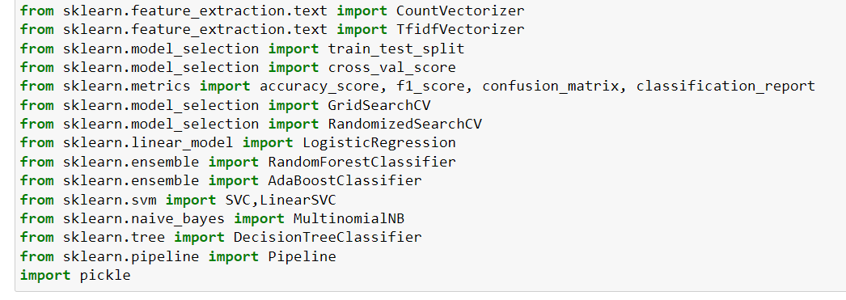

IMPORTING AND DOWNLOADING NLP TOOLS :

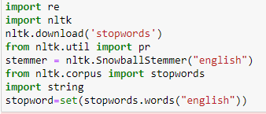

LOADING DATASET :
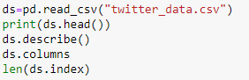

Here, we would be converting the target variable into a discrete variable as we would be working with decision tree classifier.

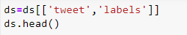
Here, we would be visualizing the changes we have made.

USER DEFINED FUNCTIONS:

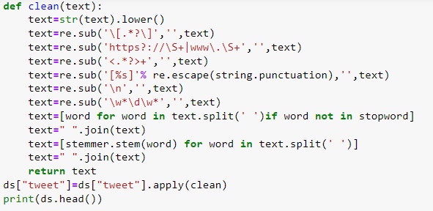
The inbuilt function clean is used to remove the unwanted gibberish or symbols from the tweets that are in the dataset.
Function to remove emoji’s in text:

SPLITTING THE DATASET:
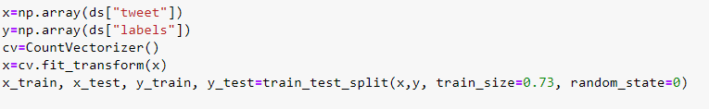

CREATION AND TRAINING OF DIFFERENT MODELS:

- Decision Tree Classifier
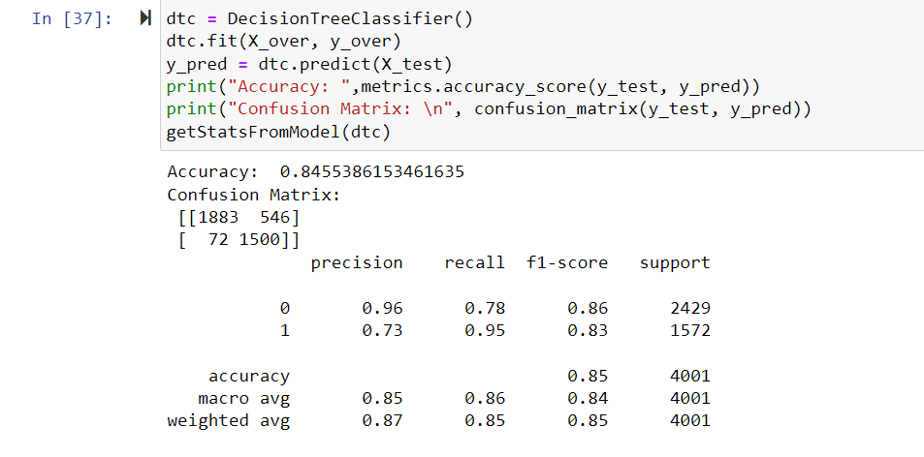
- Support Vector Machine
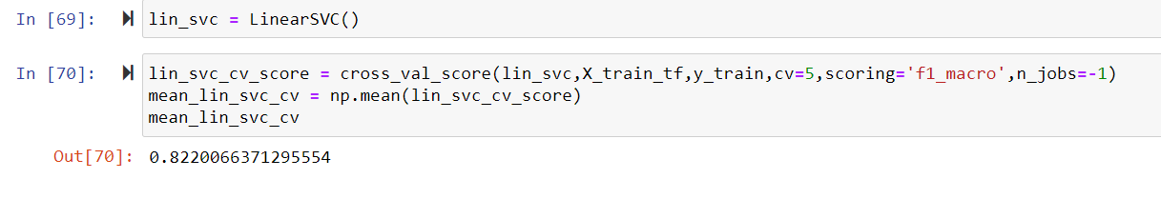
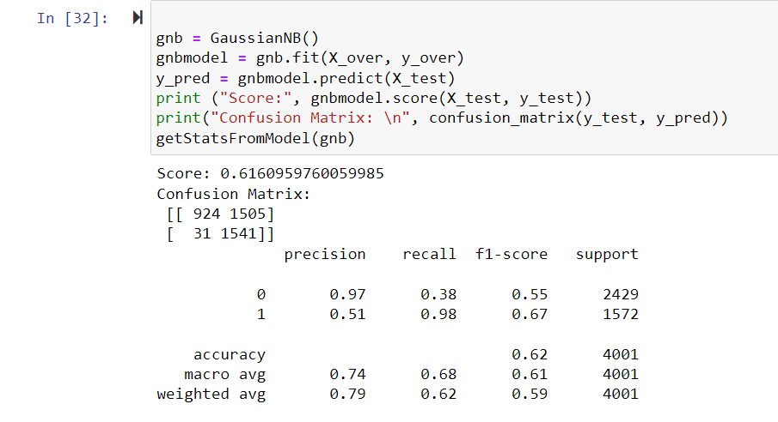
- Naïve Bayes
- Logistic Regression:
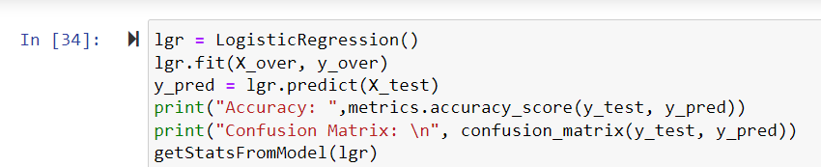

Logistic Regression Confusion matrix:
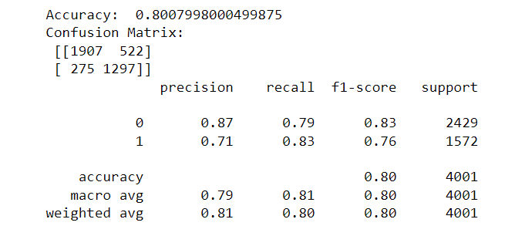
TESTING THE MODEL :

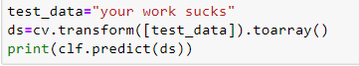

RESULT

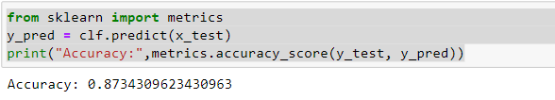

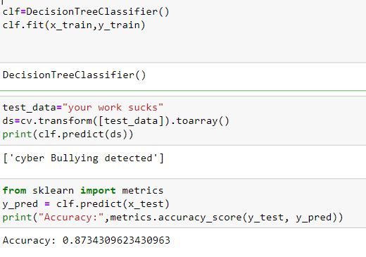
The four machine learning methods Support Vector Machines (SVM), Random Forest (RF), KNearest Neighbors (KNN), and Logistic Regression (LR) were used to compare the performance of the count vectorizer and term frequency-inverse document frequency and to select the best feature extraction model. In this paragraph, we outline:

Analysis of two feature extraction algorithms in comparison. According to the below plot, the two algorithms that provide the best accuracy are random forest classifier and logistic regression. Random Forest provides 90%, respectively.
Even though Random Forest has the highest accuracy (90%), training and output prediction require longer.
As a result, we were able to effectively extract the data, clean it, and visualize it using different Python libraries.

Comparing different Machine Learning Techniques:
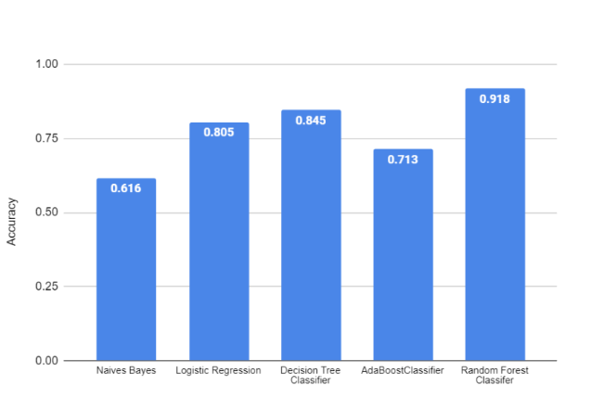

VIII CONCLUSION AND DISCUSSION

A. CHALLENGES FACED:
1) Long Execution time: Running all of the 450 experiments in the first set was challenging since it required a huge amount of time to complete. To overcome the slow execution time of the models, the experiments were conducted in parallel on high-performance compute nodes in Compute Canada clusters.
2) Random under sampling: The use of random under sampling had a negative effect on model’s performance. This can be due to the huge loss of information that happens when using this under sampling method. It is possible to experiment with over sampling techniques in the future to overcome this issue.

FUTURE WORK:

Along with the laws that are used to punish those people who cause cyber violence having an system that automatically detects the context of cyberbullying and changes it into a positive comment will be of great help as the saying goes prevention is the best .Using this will prevent lot of people from depression ,low self-esteem and also suicides.it also never let the users to use the social media as a tool to humiliate or bully others .The cyberbullying detecting system will lead to healthy environment on social media .It can be embedded into all social media and messaging apps.

IX REFERENCES

